Overview
AbCS – Audio book Collector Scanner, is an Audio Book collector database application with full search capabilities for Titles, Authors, Genre, and Series. AbCS can import Audio Book details from the data stored in the ID3Tags of each audio file. The Scan will include all subfolders. The import can scan all standard audio formats. The Audio Book data that is collected during the scan are Book Title, Author, Year, Genre, Duration, etc. See Import Tag Table below. You can also manually enter new books and edit existing ones. The Update Window allows the mass addition/update of Series and Genre.

The application is designed to be accessible to those folks with low vision or that use a screen reader. All controls and fields have shortcut keys using alt and a letter. All windows use salable fonts shortcut keys to zoom in or out. In addition, font and background colors can be set by the user in preferences.

Shortcut keys
Throughout the application shortcut keys, Alt or control keys followed by a single letter, are used to provide quick access to fields, buttons, and combo boxes. These keys are denoted by an underscore on the letter. E.g. To access the Menu combo box on the Audio Book or import window pressing alt-f will move to the File Menu. The Menu at the top of the main application window is a standard menu with include File, Edit View, etc.

Application scaling (zoom in or out) Shortcuts
- Ctrl+Plus – zoom in
- Ctrl+Minus zoom out
- Ctrl-Zero reset zoom to default

Using the Application
The first time the application starts, if there is no data in the application or on the Import list a message box is displayed. Select Import to scan Audio Books located on the computer or select New to enter data manually. If items exist in the database, then the Audio Book Window (main Window) is displayed.

Main Window – book list
Main window 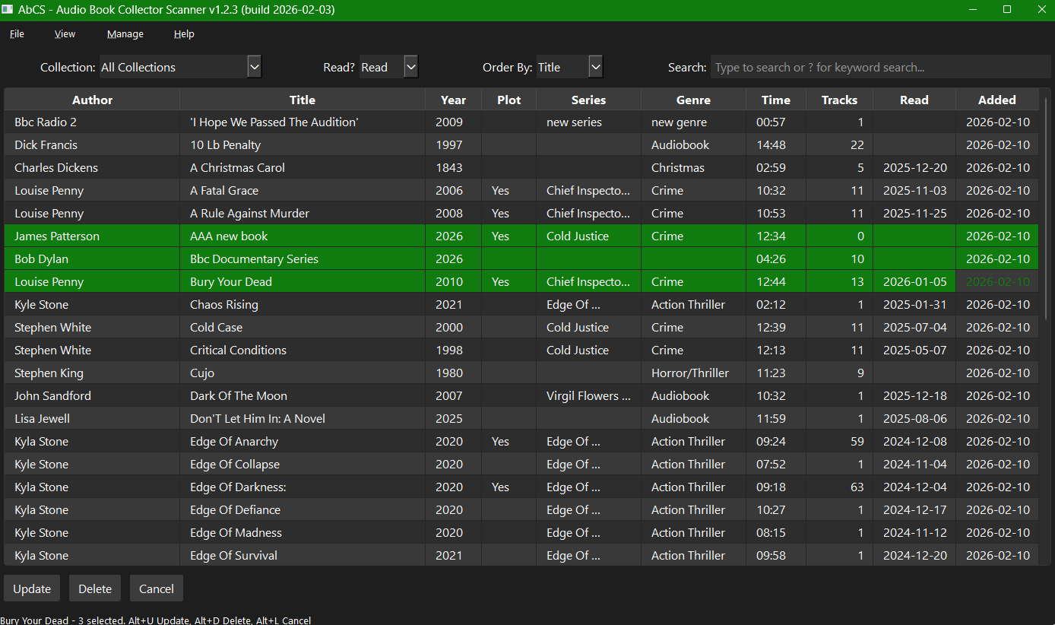

Main Window Header
The app main menu system
- file menu alt-f
  - New Book ctrl+n
  - Import
  - Quit ctrl+q
- View alt+v
  - Book Details ctrl+enter
  - Author
  - Genre
  - Series
  - Zoom In ctrl+plus
  - Zoom out ctrl+minus
  - Reset zoom ctrl+0 (zero)
- Manage alt+m
  - Preferences
  - Backup, Restore
  - Statistics
- Help + alt+h
  - About AbCS
  - Shortcut Keys F1

Below the menu bar, there are three combo controls and one text box, left to right.
- Collection alt-c - if multiple collections exist this allows you to Switch between them or all Collections.
- Read? alt-r – Allows filtering of books by All, Read, and Unread. Only books matching the selection are displayed.
- Order By alt-o Change the sort order. And search scope. choices are:
- Title – search Titles, sorted by Titles.
- Author – search Authors, sorted by Author, Year, Title
- Genre – search Genre, sorted by Genre, Title, Only books with a Genre are displayed.
- Series - search Series, sorted by Series, Year, Title. Only books with a Series are displayed.
- Search alt-s Search will move to the first item in the list of books. Only the current Collection is searched unless All is selected for Collection.
- Enter text in the Search box, the list will filter as you type, if the item exists. Pressing enter will move The focus to the first records that match the selection.
- To do a keywords search enter a “?” question mark, followed by a word or phrase to search within an item and press enter. Only records containing the search phrase are displayed. enter will move The focus to the first records that match the selection.
- Pressing Enter is search will move the focus into the book table into Author, Title, Genre or Series, depending upon the setting of Order By combo
- Press the escape key to clear search result.

Book list Window detail.
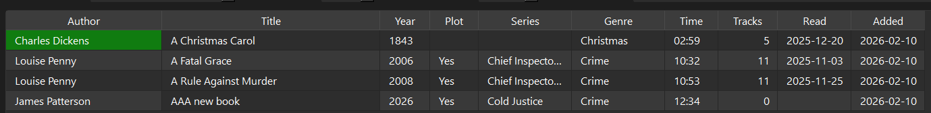
A continuous list with the following columns fields.
Author, Title, Year, Plot, Series, Genre, Time, Tracks, Read, Date-added
- Press Control+Enter or double-click to open the Book Details Window for viewing and editing.
- To select books for updating or deleting;
    - Keyboard press Shift+Space to enter select use shift up / down arrows to select multiple books.
    - Mouse use ctrl+click or shift+click for multiple selection
  - As books are selected the status will display the last book selected title and thee number of books selected.
  - To clear the selection press alt-l for Cancel or click Cancel button. Moving any of the arrow keys or clicking the mouse will clear the selection

Main Window Footer
The footer section has three buttons
The buttons are only visible if one or more books are selected.
- Update – alt-u opens the update Window where you can mass update Series, Genre and if more than one collection exists change the collection.
- Delete alt-d – deletes selected books, a confirmation message will appear. Choose Yes to delete the selected books or choose No to cancel.
- Cancel – alt-l clears any titles that are selected and hides the Update, Delete and Cancel buttons.
- Status Bar – show xx books in collection… sorted by title, author, etc. Search results and selection messages

Main Window Shortcut Keys
Collection – alt+c
Read – alt+r
Order by – alt+o
Search – alt+s
Book Detail – alt-b Move focus to the book detail list
Update – alt-u
Delete – alt-d
Cancel - alt+l

Book Details Window
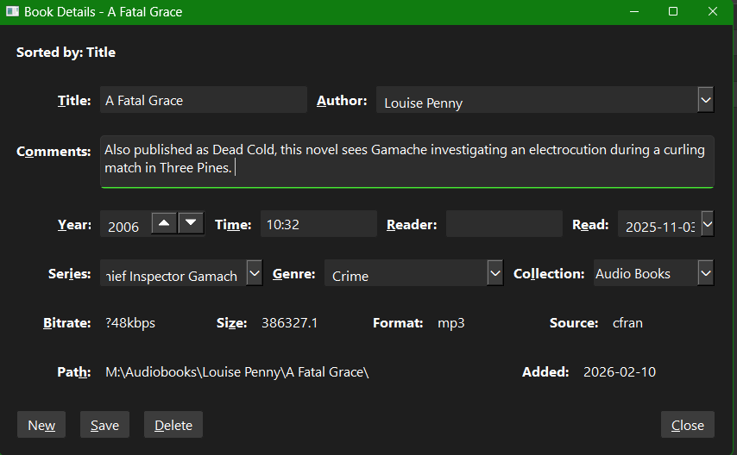

Book Details Window Header
One text box displays the current sort order. e.g., Title, author which was set in the Main Window.

Book Details Window - Details
Single Window with fields laid out in eight rows and three columns all fields are text box unless stated otherwise. All books detail date can be updated here. As you tab through the fields the cursor is placed at the end of the text within each fields. Combo boxes for Author, Collection Series and Genre are set not to use the arrow up / down keys to prevent accidental changes. TO change the value of a combo box use alt+down arrow to expand the drop-down list. To locate an items in list use up / down arrows or type to jump to an item in the combo list.
- Row1 – Title alt-t,
  - Author(combo) alt-a
- Row2 – Comments alt-o – comments such book plot, etc. (plain text format)
- Row3 - Year alt-y
  - Time alt+m format is hh:mm
  - Reader alt+r
  - Date Read alt+e format is 4 digit year – 2 digit month – 2 digit day. When in the date read fields use tab / shift+tab to move from year, month and day.
- Row4 – Series(combo) alt-I
  - Genre(combo) alt+g
  - Collection(combo) alt+l
- Row5 - Bitrate alt-b
  - Size alt-s – in MB
  - File Format – Mp3, etc.
  - Source – windows user-id of the window’s user id used to do the import.
  - Row6 – Path alt-h – Location of book when imported. Control+Enter or double-click to open the path if it exists.
  - Date Added alt-e

Book Details Window - Footer
There are four buttons as follows:
- New control+N – Clears the Window for input. Collection and date added fields are auto filled.
- Save – alt-s – this button is visible when any changes are made to the book data.
- Delete alt-d – deletes the record being displayed. A message confirming the deletion will appear.
- Close alt-c or escape closes the Detail window and return to the Main book list window.

    - Page-Up move to the previous title.
    - Page-Down move to the next title.

Book Details Window Shortcut Keys
Press alt follow by key letter below:
'T': ('Title', 'title_edit'),
'A': ('Author', 'author_combo'),
'Y': ('Year', 'year_edit'),
'F': ('Files', 'files_edit'),
'I': ('Series', 'series_combo'),
'G': ('Genre', 'genre_combo'),
'R': ('Reader', 'reader_edit'),
'L': ('Collection', 'collection_combo'),
'M': ('Time', 'time_edit'),
'S': ('Size', 'size_edit'),
'B': ('Bitrate', 'bitrate_edit'),
'H': ('Path', 'path_edit'),
'O': ('Comments', 'comments_edit'),
'E': ('Date added', 'added_edit'),
'W': ('New book', 'new_button'),
'V': ('Save', 'save_button'),
'D': ('Delete', 'delete_button'),
'P': ('Previous', 'prev_button'),
'N': ('Next', 'next_button'),
'C': ('Close', 'close_button'),

Update Window
The update Window provides the ability to mass updates or remove; Series, Genre and Collection for selected books.
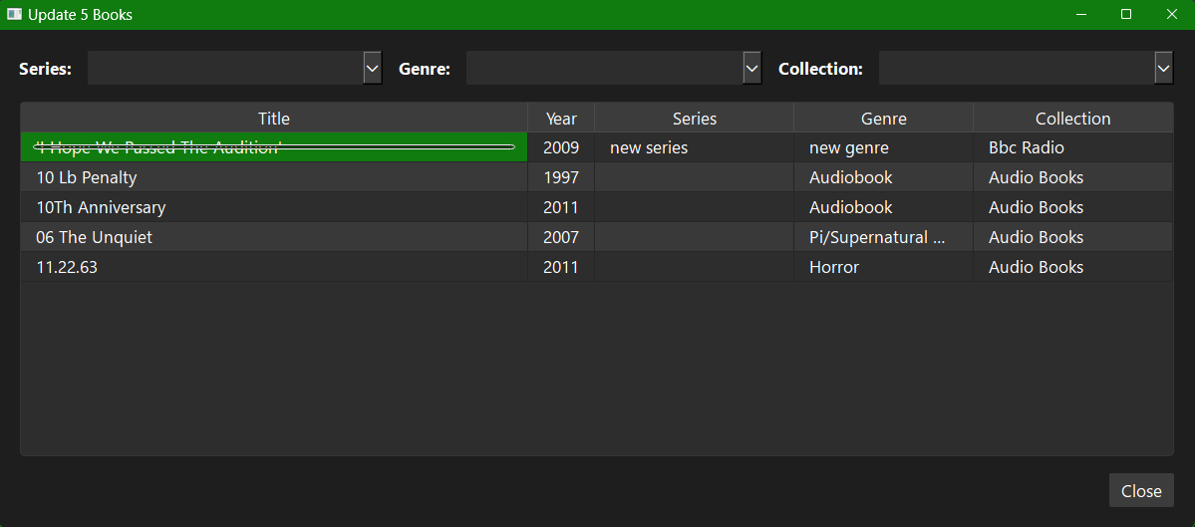

Update Window Header
Three combo boxes Series alt-s, Genre alt-g and Collection alt-l Collection is only visible if multiple collection exists. Select a series and/or genre from the list or enter a new one, or select None from the list to clear the item.
Updates occur as soon as a Series, Genre or Collection is change and either enter or tab is pressed

Window Update Details
A continuous list of books that were selected in the Book list Windows with the following fields, Title, Year, Series, Genre, and Collection.

Update Window Footer
Close button alt-c or Escape.

Update Window Shortcut Keys
Press alt follow by key letter below:
'S': ('Series', 'Series_combo'),
'G': ('Genre', 'genre_combo'),
'L': ('Collection', 'collection_combo'),
'C': ('Close_button'),

Import Window
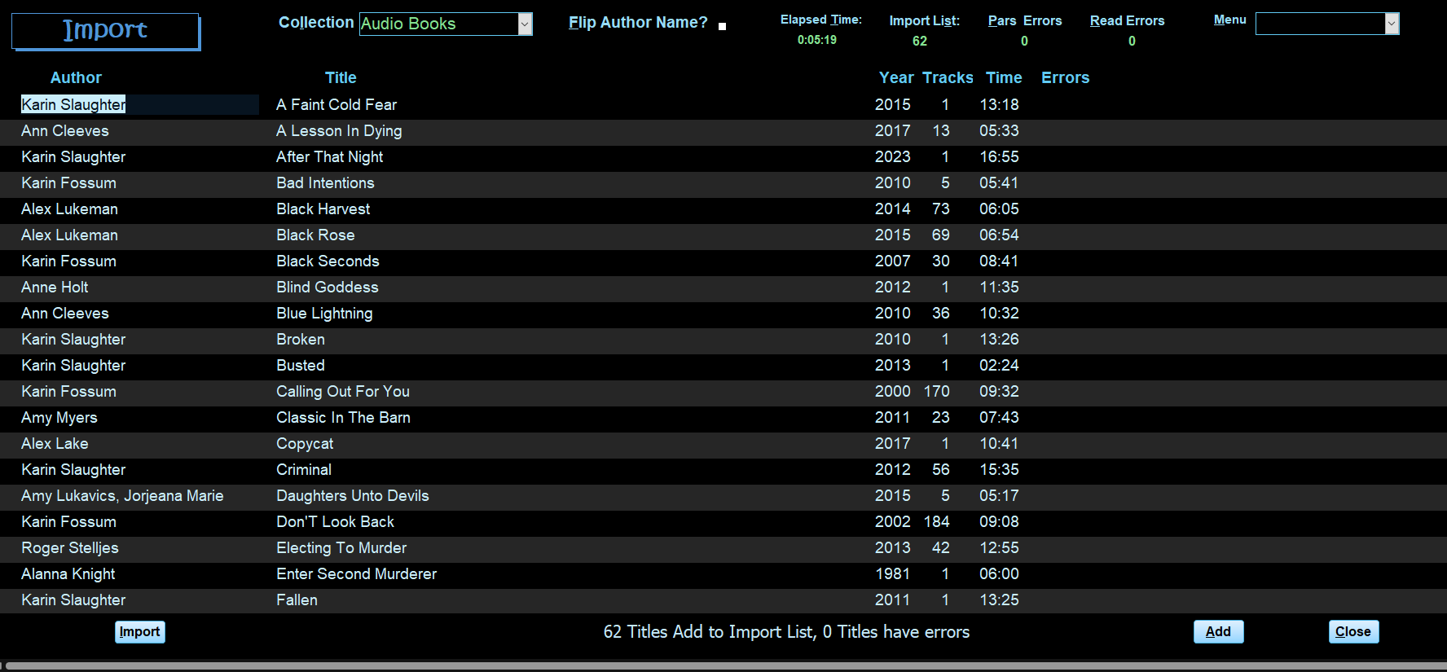

Import Window Header
The Header has the following controls left to right.
- Collection (alt-l) combo choose a collection. If only one collection exists in the database. It will default to that collection. If more than one Collection exists, then choose a collection from the combo box. Pressing Control+enter or double-clicking will open the Collection Window.
- Flip Author Name (alt-f) Check box flips the author’s name to last, first, default is unchecked.
- Elapsed Time: alt-t time the import took to complete hh:mm.
- Import List: alt-s number of records without errors.
- Parse Errors: alt-p, number of records that have errors, e.g., no author, etc.
- Read Errors: alt-r number of records, caused by corrupted file.

Import Window detail
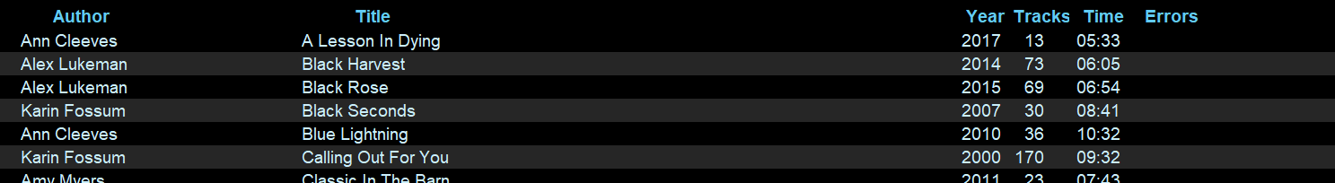
A continuous list with the following fields.
Author, Title, Year, Tracks, Time, Errors. All are plain text boxes.
Pressing Space Bar on a title will toggle the book from add to errors or vice versa.
Pressing F8 or double-clicking on a title with errors will open a detail Window that displays all data. This Window allows you to view/edit the item with errors.

Import Window Footer
Five buttons as follows:
- Import alt-I or F9 – Prompts for a folder to scan. All subfolders are scanned for tags. The prompt is a normal windows explorer dialog box. Select folder and click OK.
- Export alt-x – Exports a list of errors to a standard spreadsheet file.
- View alt-v – Open a detailed view of the book with errors, or F8 when cursor is in the title field.
- Add alt-a - Add the records without errors to the database.
- Close alt-c or F4 - close the Import Window. If there are no Audio Books in the database, the application closes. If Audio Books do exist, the Audio Book window will open.

Import Detail Window
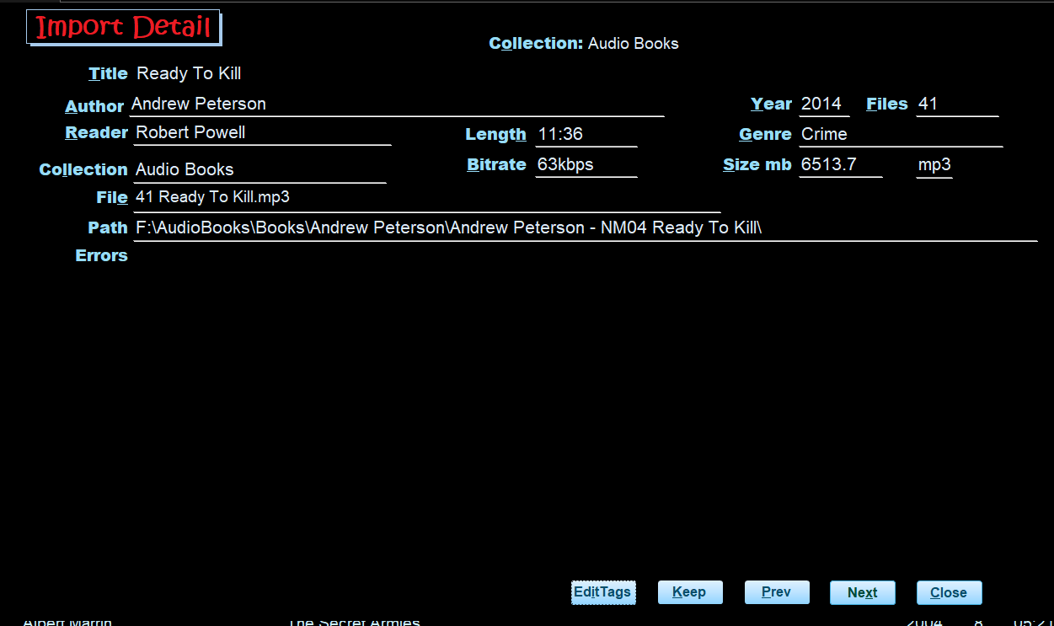
The data in this window is fully editable thus can be changed with no edits.

import Detail Error Header
Current Collection

import Detail Error Detail
Single Window with fields laid out in seven rows and three columns all fields are text boxs.
- Row1 - title alt-t
- Row2 -Author alt-a
  - Year alt-y - year the book was published.
  - Files alt-f - number of files
- Row3 - Reader alt-r
  - Time alt-m hour and minutes
  - Genre alt-g
- Row4 - Collection alt-l
  - Bitrate alt-b
  - Size alt-s – in MB
  - File Format – Mp3, etc.
- Row5 - Path alt-h - The location of the audio files. F8 or double-click to open the path in Windows File Explorer
- Row8 - Errors alt-o – List of the audio files and related errors. See Import Errors Description table below.

import Detail Error Footer
There are five buttons located at the bottom.
- Edit Tag – alt-I –open the Audio Book in a tag editor. This button is only visible if Mp3Tag or Tag Scanner is installed on your PC.
- Keep – clears the error flag and moves to the next record with errors.
- Prev alt-p, Next alt-n, or page-up and Page-down move between error records
- Close alt-c or F4 returns to the Import Window.

Importing:
From the Import Window:
- Click the Import button or press F9 or alt-I to start the import. (If any books exist on the import list you will be prompted to ask if you want to keep them. Click Keep alt-k or Delete alt-d .)
  - 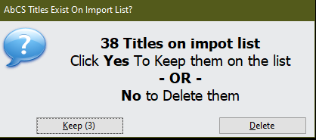
- Select the folder you want to scan and click OK.
- All controls on the window are locked during the import process. If there are many files being scanned a windows Shell Window may appear and it will go away on its own.
- The Importing Status window will display.
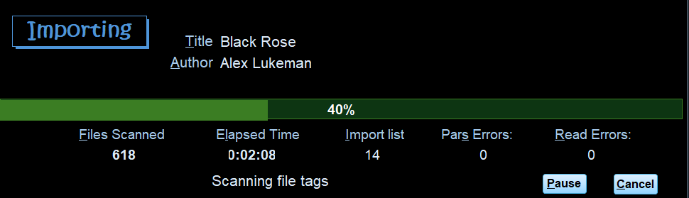
This window displays import progress and counts.
  - Title: alt-t and Author alt-a the current book being processed
  - Error alt-e – only display if the current book has an error.
  - Files Scanned alf-f the number of audio files scanned.
  - Elapsed Time alt-t
  - Import List alt-s – number of books added to the Import list.
  - Parse Errors: alt-p, number of records that have errors, e.g., no author, etc.
  - Read Errors: alt-r number of records, caused by corrupted file.
  - Message box.
  - Pause button alt-p – pauses the import.
  - Cancel alt-c – A message box confirming will be displayed.
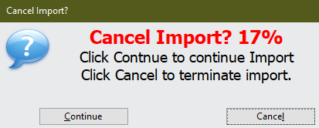

When the import is completed press the Close alt-c button to close the Importing Status window.
The import window will display the books that were imported and any errors.
- Press the View button alt-v – Open a detailed view of the book with errors, or F8 when cursor is in the title field. See Import Detail window below.
- Click Add or alt-a to add all books imported without errors to the database.
- If there are no more books on the import list the import Window will close, and the Audio Book Window is displayed. If errors exists the Import window will remain open.

Collection Window
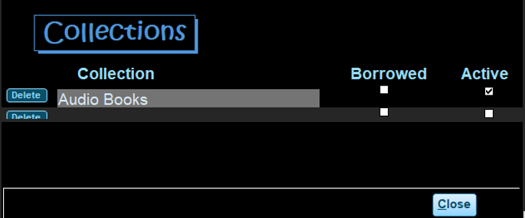
Collection Window Header – no controls
Collection Window Detail
Three controlls
- Delete button
- Collection name
- Active checkbox – If checked then the collection is shown in the Collection combo on the Audio Book and Import Windows. To hide a collection uncheck the Active checkbox.
Collection Window Footer – Close alt-c or F4.

Author, Genre, and Series Windows
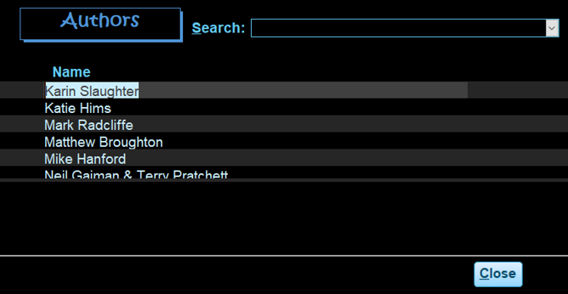
These three Windows are similar with the same controls and layout. They are for making corrections to Author, Series or Genre.
Author Window Header - Search combo box to quickly move to a particular Author.
Author Window Detail - Continuous list Author Name.
Author Window Footer – Close alt-c or F4.
Note: Author, Collection, Genre, or Series cannot be deleted if there are books associated with them.

Backup/Restore Window
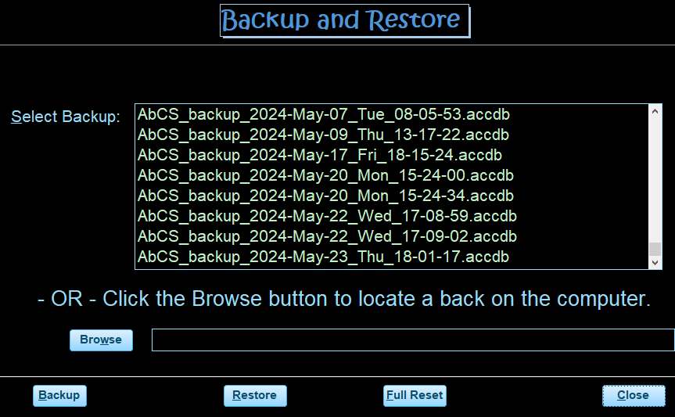
Backup/Restore Window Header – no controls

Backup/Restore Window – detail
- Listbox – list existing backups
- Browse button – to select a backup that is located somewhere other than the default backup folder
- text box – Display the name of the backup file to be restored.

Backup/Restore Window – Footer
Four buttons:
- Backup alt-b – creates a backup of the application in the default bacckup folder
- Resore alt-r – Restores the application from a selected backup
- Full Reset alt-f – Clears all data in the application.
- Close alt-c or F4 – Close the Backup/Restore window.

Backup files are names are: AbCS_backup_yyyy-mm-dd_ddd_hh-mm-ss
e.g. AbCS_backup_2024-May-17_Fri_18-15-24.

Import Errors Description
Error messages | Cause / tag issue
Author Blank | Blank tag for Album Artist and Artist tag
Author name in Title | Title contains author name (not always an error)
Author Name is 'Artist Album' | Album Artist and Artist tag are null
Author Name is 'Unknown Artist' | Unknown in Album Artist and Artist tag
Author Name Starts with | Author name begins with non-alphabetic character
Duplicate Author & Title | Duplicates are those records having the same Title, Author, Year and Collection
File not found | The folder/files being scanned have move – usually caused by USB drive being disconnected from the computer.
Read Error | Unable to read the file. Usually due to corrupted tags in the file.
Title Blank | Blank tag for Album is blank
Title in Author name | Book title appears in Author Tag

ID3Tags scanned during import:
Book Data Field | ID3Tag Source
Book Title | Album (13)
Author | Album Artist (237) if empty Artist (13)
Size in MB | TrackSize (1) in kb accumulated if multiple files.
Time in hours & minutes | Track Time (27) accumulated if multiple files.
Release year | Year (15)
Audio Quality | Bitrate (28) in kb
Genre | Genre (16)
Comments | Comments (240 accumulated if different in each file of a book. Scan for “read by”, etc.
Reader/narrator | Composer (243) sometimes contains the narrator/reader.

